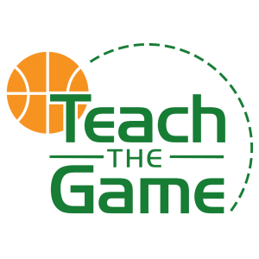

TTG/MADDAWG/WSS/CRC Invitational RULES
Revised January 2021
COVID-19 PROTOCOLS: The Winston-Salem Stealers and Teach The Game will try and provide as safe as an environment as possible for the tournaments and events we host. We will screen before each game, clear the gym after each game and keep the facility as clean as possible throughout the day.
We ask that any player, coach or spectator that isn’t feeling well to stay away from the facility as a precaution. Facemask policy: Beginning December 2020, all participants, spectators, coaches, visitors to The Maddawg Center must wear a face mask at all times. Only the spectators of the teams playing are allowed in the facility. Please follow these procedures to make our events as safe and fun as possible.
North Carolina High School Athletic Association Rules with the exception of any rules listed below:
- Team listed first will wear white/light jersey & keep official scorebook at the table.
- Two sixteen minute halves, running clock. Clock stops the last two minutes of the second half if the score is within ten points.
- One minute halftime.
- Two, 30 second timeouts per half. Timeouts do NOT carry over from 1st half to 2nd.
- Home team scorekeeper MUST HAVE BOOK READY TO GO, and BE AT THE TABLE prior to game time, NO EXCEPTIONS. Visiting team scorekeeper must be ready by then as well, but game will start regardless of visiting scorekeeper's readiness.
- SCOREKEEPER CANNOT COACH OR YELL FROM THE TABLE!!
- Player, Coach, or Staff ejections will result in a one game suspension, or removal from the tournament by the Tournament Director
- GAME TIME IS GAME TIME. There is no grace period; if a team is not ready to play at game time it is a forfeit. Be ready to play at least 15 minutes prior to game time.
- Overtime period will be sudden death – first to score at least one point wins. Clock will run for 3 minutes, if sudden death does not end the game it will end in a tie.
- No music/boomboxes inside the gym/facility at warmups or any time.
- Note: per NCHSAA rules, no earrings, including covered earrings. Must be removed.
Bench Passes: we only give passes to coaches/bench personnel that sign in, up to 3 passes allowed. Only Coaches/Bench with coach wristband will be allowed on the bench
NOTE: Licensed Athletic Trainers may be on-site to handle all injuries/concussions. Licensed Athletic Trainers are licensed healthcare professionals that are formally trained in the recognition, evaluation, management, and rehabilitation of injuries that occur during physical and athletic/sport activity. The Winston Salem Stealers follows the Gefeller-Waller concussion law and NCHSAA concussion management protocol.

